**Student Learning Experiences and Activities Y7-8**

**‘Up the Pipe’ Supporting Information for Teachers**

**Introduction**

**The teaching resource PDFs produced for Y7/8 are designed to be used in conjunction with one another.**

**PDF**

1. **Lesson Plan Y7/8 Curriculum levels 3,4,5**

This provides the start of teacher’s lesson plans and contains achievement objectives, theme, future focus, key competencies, values and cross curricular links for each curriculum level. Read this then look at PDF 2 to select learning activities.

OR

There is a complete Science Unit lesson plan for the different Curriculum Levels.

1. **Y7/8 Learning Experiences and Activities**

This is a learning ideas panel, **the experiences are not numbered in any particular order**. Some may need to be used in conjunction with one another e.g. 25. Intro to water and 27. Water. The panels provide a range of different lesson ideas and activities for teachers to select from to complete their lesson plan, and ideas where the lesson could be integrated as cross curricular activities. This is to enable teachers as much flexibility as possible to select lessons that fit within their time frames and own school curriculum.

1. **Y7/8 Teacher Resources**

This provides the teacher with the information and templates they require to be able to teach the lessons in PDF 2 the Learning experiences.

**The Y4/6 and Y7/8 learning idea panels are very similar with a few that differ by having a basic or more complex task. Teachers can extend or simplify to suit their students’ needs.**

|  |  |  |  |
| --- | --- | --- | --- |
| **1**.  Brainstorm prior knowledge about household products.  What ingredients are in them?  If they are safe for us to use are they safe for the environment? Where do they go when we flush them down the drain?  Do we need to make different choices of products, why?  How can we convince people to change their choices? | **2.**  House activity – interactive practical activity with household products | **3.**  Poster  Design posters to:  Show chemicals found in household products.  Sell an environmentally friendly product.  Show traditional cleaning products.  Convince people to choose environmentally friendly products. | **4.**  Product making  Bath product/shower bag  Hand scrub  Foot powder  Bath bombs  Dry shampoo |
| **5.**  Stream life  How can you tell if it’s healthy | **6.**  Stream visit  Observe. Make notes of what you see.  Is your local stream clean/healthy?  What evidence do you have to support this? Write it up. | **7.**  Water treatment video  Learn about how water treatment plants work. | **8.**  Water treatment plant  Small group work  Students discuss/think about process and draw in correct order. |
| **9.**  Survey  Complete part 1 of survey at school.  Take home part 2 to interview parent. | **10.**  Research  Using books, online articles, google, photographs, library history, research  Traditional cleaning products.  Environmental effects of household products on local streams. What could happen and why?  Comparisons between regular household products and environmentally friendly products, include, ingredients, price, packaging, effectiveness etc. | **11.**  ESR research –Bugs that glow in the dark  What are they?  How can they be used? | **12.**  Changing habits – looking at advertising  Small group work  Students discuss/think about and record ideas about how pwople make choices and ways to change people’s choices in favour of environmentally friendly |
| **26.**  **Water**  Where does it come from?  How much water is there for us to use?  Where is all the water?  **See 25.** | **28. Build your own water filter.**  Simple, quick and easy practical session for students, with instant results.  Write experimental report. | **29. PACMAN**  End of day science quiz –  Fun quiz on science (and other subjects) you have been learning recently. | 30. Create your own water cycle  Simple Practical activity |

**Student Learning Experiences and Activities Y7-8– Science**

**Student Learning Experiences and Activities Y7/8 – Integrated subjects**

|  |  |  |  |
| --- | --- | --- | --- |
| **Maths**  **13.**  Interpreting survey data | **Literacy**  **14.**  Subject reading about  Environmental changes  Waterway health- streams  Water treatment plants  Stream life – ecology / habitats | **ICT**  **15.**  Poster production for publication | **Drama**  **16.**  Dramatisation of historical events  Sanitisation through the ages, locally  (See **26**.) |
| **17.**  Drawing graphs/charts | **18.**  Report writing | **19.**  Report generation | **25.**  He taonga te wai  Water interview  Short introduction to water |
|  | **20.**  Dictionary work-  Coagulation  Particle  Alum  Floc  Clump  Sedimentation  Filtration  Disinfection  Chlorine  Bacteria  Organisms  Reservoir  Filter  Sustainable  Microinvetebrates  **Add any other new words to list** | **21.**  Write detailed description about what happens at each stage in a water treatment plant. | **ART**    **24.**  Poster production  Draw, paint, collage. |
| **23.**  River scenes healthy/polluted  Draw, paint, inks, collage. |
|  | **22.**  Debate –  What makes people continue to do things that are bad for the environment?  What would make people change their habits? |  | **27.**  Cartoon strip to record historic events play |

**Lesson Ideas**

1. **Brainstorm – determine student’s prior knowledge**

Which cleaning products do you use at home?

Do you know ingredients are in your products?

Where do they go when we flush them down the drain?

If the products are safe for us to use, are they safe for the environment?

Where do they go when we flush them down the drain?

Do we need to make different choices of products? Why?

How can we convince people to change their choices?

1. **House activity – Discussion starter**

Print off, trim to shape and laminate house picture and household product pictures in Teachers notes PDF file.

Stick together A4 parts of house to provide a large house picture.

Hand out a selection of products to each student.

Where would these products be used? Students take turns to stick products onto house where they are used.

Discuss how many different products there are on the house now, talk about how many products go down the drain in their own homes.

What do they think happens to these products?

What effect could this have on the environment?

How can we make better choices?

1. **Posters**

Student’s choice of subject from list below, to design a poster either hand drawn, painted, collage, photographs, or using computer to publish

Subjects:

House hold products and chemicals they contain

Sell an environmentally friendly product

Compare traditional and modern day cleaning products

Compare healthy and polluted streams

Show how water treatment plants clean water for consumption

Show where products go: from using in the house, to flushing down the drain, to where next?

To convince people to choose environmentally friendly products.

**Integrated subject options**

**14. Literacy** - Reading to research information about products, environment, natural

waterway health.

**15. ICT** - Researching information, pictures, photographs, history on internet. Publish

poster.

**24. Art** - Draw, paint, pastel, ink, collage to produce poster.

1. **Product Making**

***Oatmeal bath product / shower bag***

2Tbs oatmeal

2Tbs chopped herbs

* Tie up in cheese cloth with ribbon. Place bags in bath while warm water is flowing

You can also use bag as shower scrub (Remember to empty, wash and reuse you material and ribbon).

MIX together

**Resources required:**

Oatmeal, mixed herbs, cheese cloth fabric, ribbon, tablespoons

***Lemon Sugar Hand Scrub***

2 ½ cups sugar

1 cup extra virgin olive oil

4 Tbs lemon juice/preferred essential oil

MIX together

**Resources required:**

Sugar, measuring cups, Olive oil, tablespoons, lemons/lemon juice **OR** favourite essential oil fragrance, pots for product when completed

***Foot care powder***

1 cup baking soda

3 drops of 3 preferred essential oils (tea tree, lemon, mint, lavender, rosemary)

MIX together

**Resources required:**

Measuring cups, baking soda, essential oil, pots for product when completed

***Bath Bombs***

3 tbs sodium bicarbonate

1 tbs citric acid

10 drops essential oil

Mix on plate.

*Sprinkle into bath water before you step in

**Resources required:**

Sodium bicarbonate, tablespoons, citric acid, essential oils, plates, pots for completed product.

***Dry Shampoo***

This dry shampoo is ideal for people who are unable to get into a shower for medical reasons. Plus, it’s equally effective for deodorising unpleasant-smelling dog hair.

1 cup rolled oats

1 cup bicarbonate of soda.

Put rolled oats in the blender and blend to a fine powder. Add bicarbonate soda and mix well. Rub a bit of the mixture into your hair (dog hair) and leave for 1-2 minutes to soak up the oils. Next brush or shake out of your hair. Store in an airtight container.

**Resources required:**

Rolled oats, measuring cups, bicarbonate of soda, brush, airtight container for completed product.

1. **Stream Life - Stream health indicators**

Pollution sensitive = Good water quality

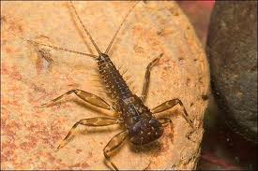 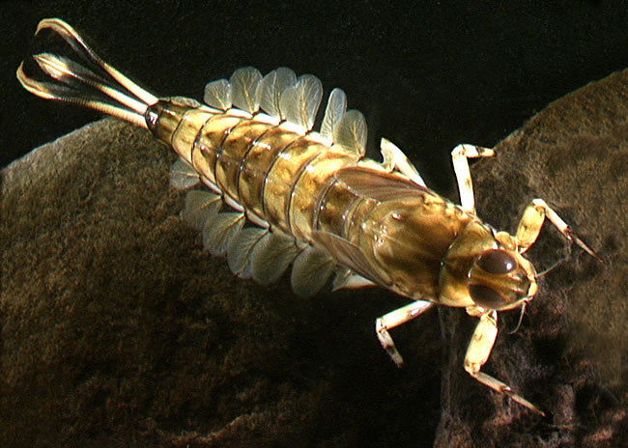

Mayfly nymph

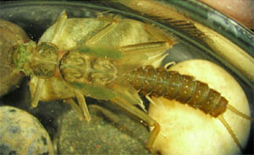 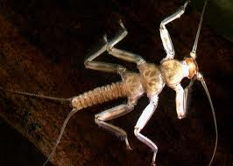

Stoneflies

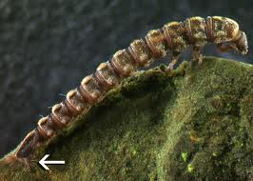 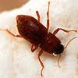

Riffle Beetles

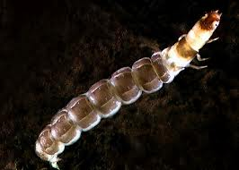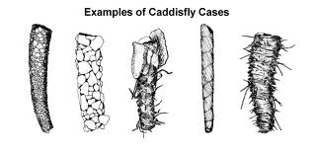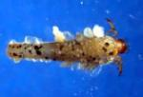

Caddis flies

Indicators that can live in a wider range of water conditions = Moderate water quality

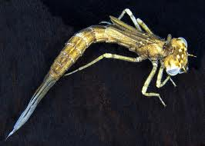 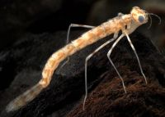

Damselfly

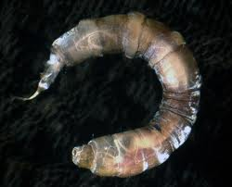 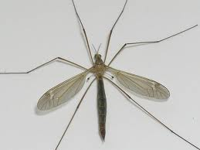

Cranefly larva Cranefly

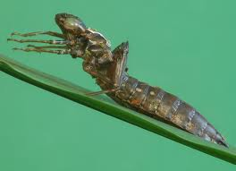 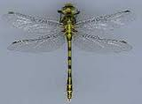

Dragonfly nymph Dragonfly

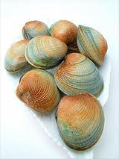 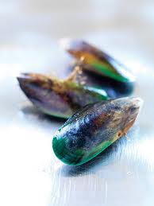 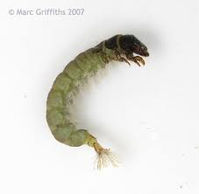

Clams Mussels Net spinning caddis fly

Pollution tolerant = Poor water quality

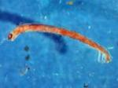 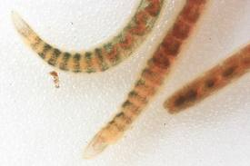

Midge Larva Aquatic worms

See Teacher resources for

What is a macroinvertebrate?

Why are they indicators of good health in a stream?

How will we use them?

1. **Stream Visit**

Field trip to local stream or river. Observe the wildlife seen and record, count numbers. What does the water look / smell like? Record.

Back at school – Is your local stream healthy? Students use your notes to make a decision. Write a report of where they went, when, what they saw, and their opinion on whether the stream was healthy or not, using evidence to support their opinion.

**Integrated subject options**

**23.** Art option – Draw, paint, collage local river scene.

**10. and 19.**  ICT option – Publish report, use internet to search for photographs and/or historical facts of the stream to include in publication.

**17.** Numeracy option – Students create Tally charts to record macroinvertebrates

during stream visit.

* Graph class results of wildlife observations after stream visit.

1. **Water treatment**

Watch ESR video on a water treatment plant.

Students discuss what they have seen. Questions.

Link to ESR video:

<http://www.esr.cri.nz/videos/findingsolutions/upthepipe-hires.mp4>

1. **Water treatment plant small group and/or individual work**

Hand out Treatment plant printout (below)

Small group work, using printout, Discussion, what happens where? how the water get cleaned?

**Integrated subject options**

10. – Literacy – Research how water treatment plant works – Books

ICT – internet search

19. - Write a report about what happens at each stage in the water

treatment plant

ICT – or an article for

Publication

20. - Dictionary work to locate meaning of all new subject specific words

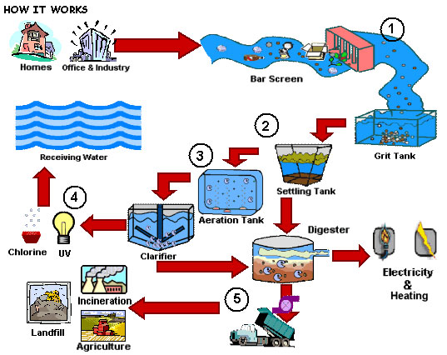

1. **Survey**

Print off surveys, one for each student (surveys in Teacher’s Resources PDF file).

Class/group discussion about the introduction on the survey, what it means, and why they are doing the survey.

Students complete part one of survey at school, and take home part two of the survey to interview main shopper in their household.

**Integrated subject options**

**13.** Numeracy –Interpret survey data

**17.**  - Use data generated to produce graph of results for class

Use results of survey to generate **discussion** about volume of products used and going down the drain, the effects it may have on the environment, and what we can do about it.

1. **Research**

After completing some of the other activities get the students to do research on any part that interests them e.g.

Traditional cleaning products

Environmental effects of household products

Comparisons between environmentally friendly and regular products, include ingredients, pricing, packaging, effectiveness

Water treatment

Making environmentally friendly products

Recent pollution events in local streams and the effects

Effects advertising, e.g. packaging, airbrushed photos etc can have on purchasing of products

Current environmental research and how it may help in everyday life

**Integrated subject options**

**18.** Literacy – Report writing

Book, magazine, articles research

**19.** ICT – Report generation and publication

- Take real life photographs for publication

1. **ESR Research – What is a biosensor? How can they be used?**

**How do they work?**

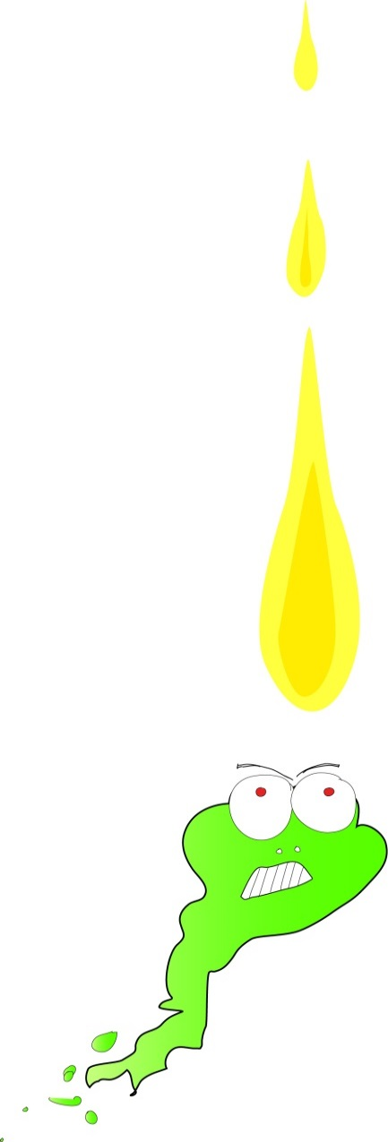

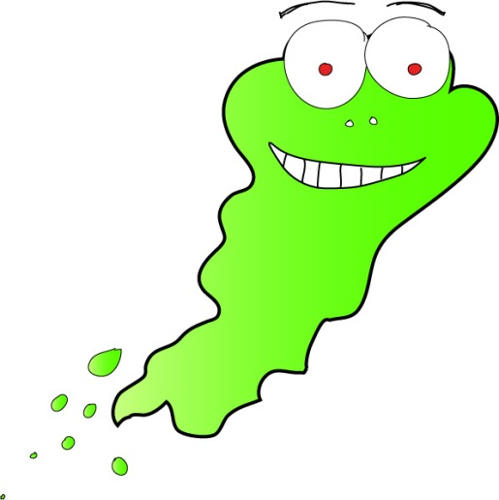

**Comes into contact with poison**

**Physiochemical change (signal) detected by transducer**

**Bio-sensing element**

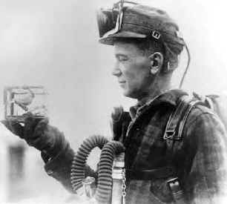

**The first biosensor**

**Bio-sensing element - canary**

**Transducer - eyes**

**Signal – dead canary!**

**How the biosensors work**

**Under normal conditions, they bioluminesce - i.e. give out visible light. The light output is directly proportional to the metabolic activity (i.e. health) of the biosensor. If they are challenged with a sample (water, soil, urine, stomach contents) which has any available toxicity, the bioluminescence will decrease in direct proportion to the level of toxicity present**

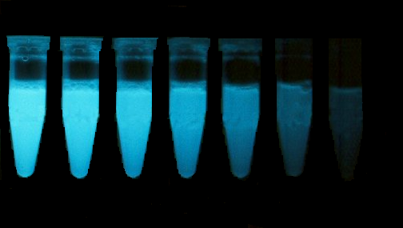

**Poison concentration**

**Bacteria indicate toxicity by switching light off**

***LUX***



***LUX***

**Apply**

**Poison**

**Happy**

**bugs**

***Lux* Biosensors**

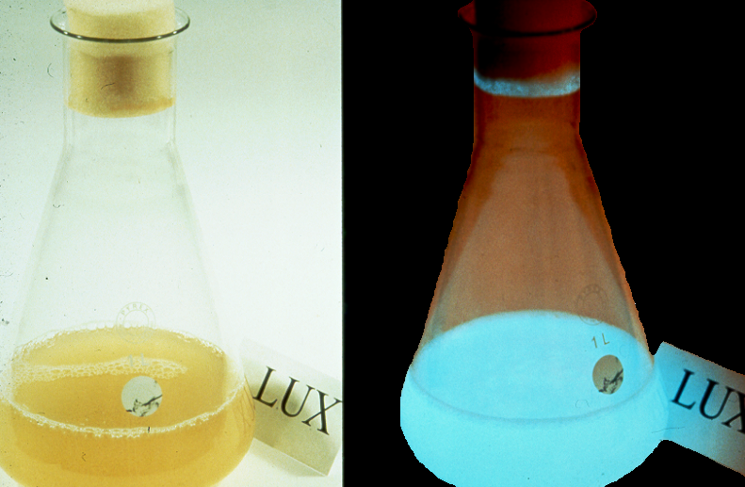 

**Darkfield image**

**Brightfield image**

LUXGENE 2000

1. **Changing habits – advertising**

Advertisers use a range of techniques to sell their products from styles to tricks of the trade.

How could you get people to change their choices to environmentally friendly products?

**Advertising Techniques Handout - Styles**

|  |  |
| --- | --- |
| **NOSTALGIA** | **Plain folks, back to nature, kiwiana, just the way Grandma used to make it, back in the good old days.** |
| **BANDWAGON** | **Everyone who is anyone is buying this product. Don’t be the only one without it. Don’t be left out!** |
| **TRANSFER/FANTASY** | **Super heros, knights in shining armour, green giants, super athletes, super models, beautiful people, rich people are featured. Advertisers hope that the consumer will tend to transfer these qualities to the products themselves and purchase the item.** |
| **HUMOUR** | **People may tend to remember an ad it if makes them laugh and may purchase the product because of the positive association with it.** |
| **SENSE APPEAL** | **Sounds or pictures that appeal to the senses are featured.** |
| **STATISTICS** | **People tend to be impressed with “facts” and statistics even if they have little or no meaning.** |
| **TESTAMONIAL** | **Important or well-known people testify that they use the product and so should you.** |

**Advertising Techniques – Tricks of the trade!**

**Advertising – Media Literacy**

**Mo****Ideology: Evolution of a supermodel**

An ideology is an absolute way of looking at things in a way of a society. The main purpose is to offer change in society, or adherence to a set of ideals where conformity already exists, through a normative thought process.   
  
<http://www.youtube.com/embed/s2gD80jv5ZQ?rel=0>

In this video by dove a model is being shown before and after she is made up and airbrushed. This ad is called evolution of a supermodel to show that even supermodels aren't perfect and are made up to appear perfect when they in fact are normal women. This topic is important because society is filled with this unrealistic fantasy to look like a supermodel. What dove has done has shown that any average woman can look like a supermodel if she is made up by professionals and airbrushed.

The issue at stake is body image and the major effects it has on society. This issue of wanting to look like a supermodel or Barbie has been an issue for a long time and dove has come up with a campaign that helps women feel more confident in the idea that looking like a super model is unrealistic.

[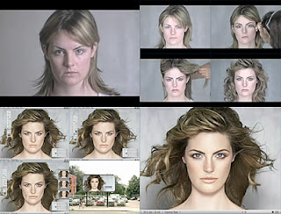](http://2.bp.blogspot.com/-FL35B_-JW8Q/Tdq5pmzCz2I/AAAAAAAAABw/kQprRT-YO1U/s1600/dove-campaign-for-real-beauty.jpg)

﻿

Although a short film of a normal woman transforming into a supermodel, this ad expresses so much more. It describes how anyone can be anything they went through the transformation of artificial products, whether positive or negative, this is an epidemic that is happening every day. Dove is showing through video how that transformation takes place, but they haven't even touched on celebrities, or what real people do everyday to make themselves look more and more like these mocked images. ﻿

Comments from video viewers:

Are ideologies really absolute? Might it be more correct to say that “absolute” and “relative” are ideological terms about which different ideologies offer competing definitions and standards? In your analysis of Dove Evolution, the main goal will be to get at some of the abstract ideological concepts that frame this video. For example, you say that the media’s power in imposing perfectionistic standards on women is a big problem. But why do the media impose those standards on women with greater force than on men? What is the hierarchy in society that makes gender hierarchies seem natural or sensible? The fact that this video is called Evolution is also an interesting point to me. It describes a process of Evolution, and seems to critique that process. But isn’t evolution natural? And doesn’t it promote the survival of the fittest? So how do we reconcile that ambiguity in Dove’s intent?

LINKS: click on links to view content[▼](javascript:void(0)) [2011](http://dnm-medialiteracyclass.blogspot.co.nz/search?updated-min=2011-01-01T00:00:00-08:00&updated-max=2012-01-01T00:00:00-08:00&max-results=6) (6)

* + [▼](javascript:void(0)) [May](http://dnm-medialiteracyclass.blogspot.co.nz/2011_05_01_archive.html) (3)
    - [Ideology: Evolution of a supermodel](http://dnm-medialiteracyclass.blogspot.co.nz/2011/05/ideology-evolution-of-supermodel.html)
    - [Gentrification In Portland](http://dnm-medialiteracyclass.blogspot.co.nz/2011/05/gentrification-in-portland.html)
    - [The Fantastic Four](http://dnm-medialiteracyclass.blogspot.co.nz/2011/05/fantastic-four.html)
  + [►](javascript:void(0)) [April](http://dnm-medialiteracyclass.blogspot.co.nz/2011_04_01_archive.html) (3)
    - [Media Lit Post 3: Mob Wives](http://dnm-medialiteracyclass.blogspot.co.nz/2011/04/blog-post-3-mob-wives.html)
    - [Media Lit Post 2](http://dnm-medialiteracyclass.blogspot.co.nz/2011/04/media-lit-post-2.html)
    - [Media Lit Post 1](http://dnm-medialiteracyclass.blogspot.co.nz/2011/04/media-lit-post-1.html)

[**dnm**](http://www.blogger.com/profile/17098215543708206612)

This is a blog site to help adolescents and parents how to transform into the formal operational stage of their life. This is aimed at helping teens make the right decisions as they are learning to think creatively and more abstract. Parents should view this blog with their teens and comments on any ideas, things that helped, and or things that didn't help.

[View my complete profile](http://www.blogger.com/profile/17098215543708206612)

|  |  |
| --- | --- |
| [**http://iamadam.org/2011/12/24/feminist-critique-of-advertising-and-image/**](http://iamadam.org/2011/12/24/feminist-critique-of-advertising-and-image/)  [**http://www.historyundressed.com/2008/07/history-of-hygiene-bathing-teeth.html**](http://www.historyundressed.com/2008/07/history-of-hygiene-bathing-teeth.html)  **you tube germ ads**  [**http://www.youtube.com/watch?v=hs0aG7gi3IU&feature=related**](http://www.youtube.com/watch?v=hs0aG7gi3IU&feature=related)  [**http://www.youtube.com/watch?v=DCOSFTugYZM**](http://www.youtube.com/watch?v=DCOSFTugYZM) |  |

Report photo





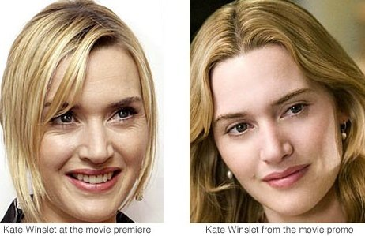

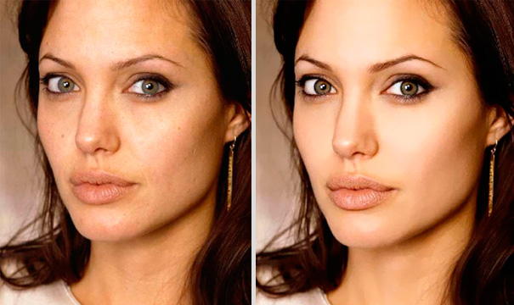

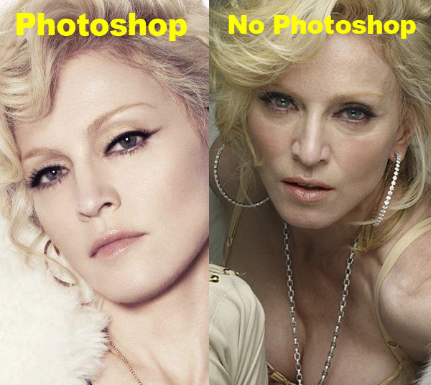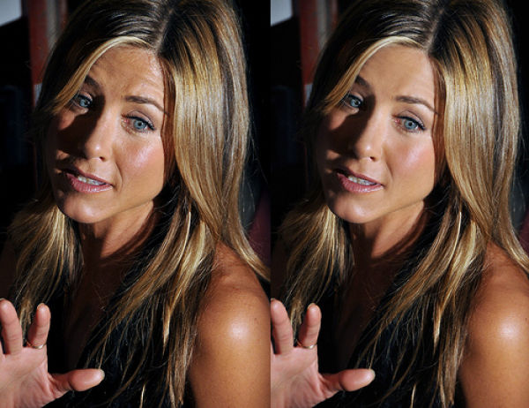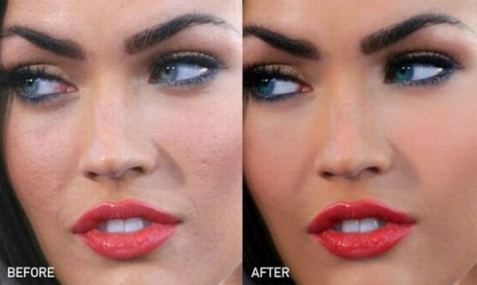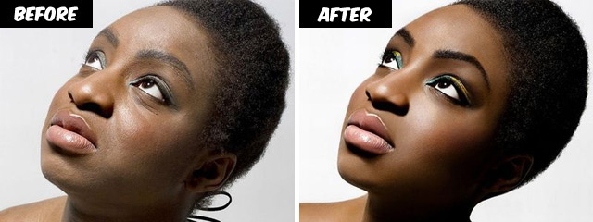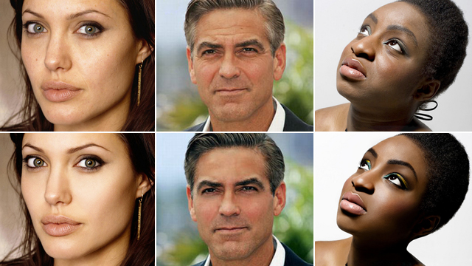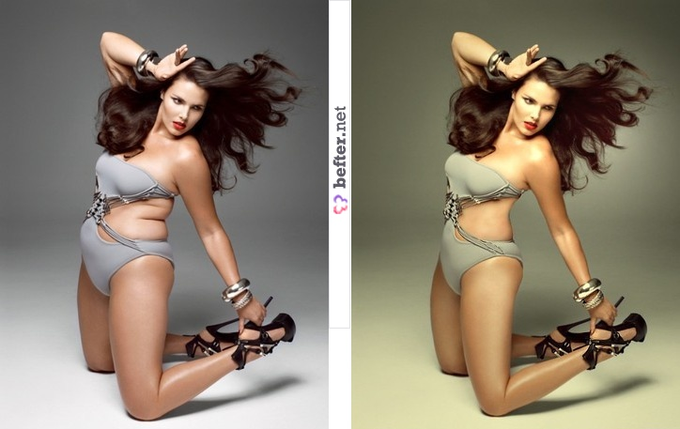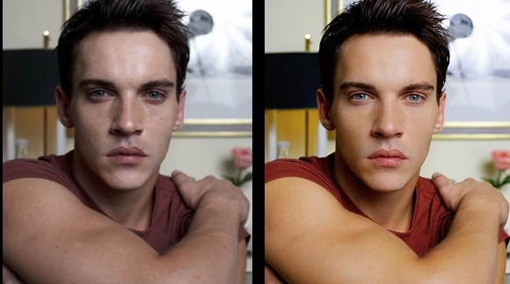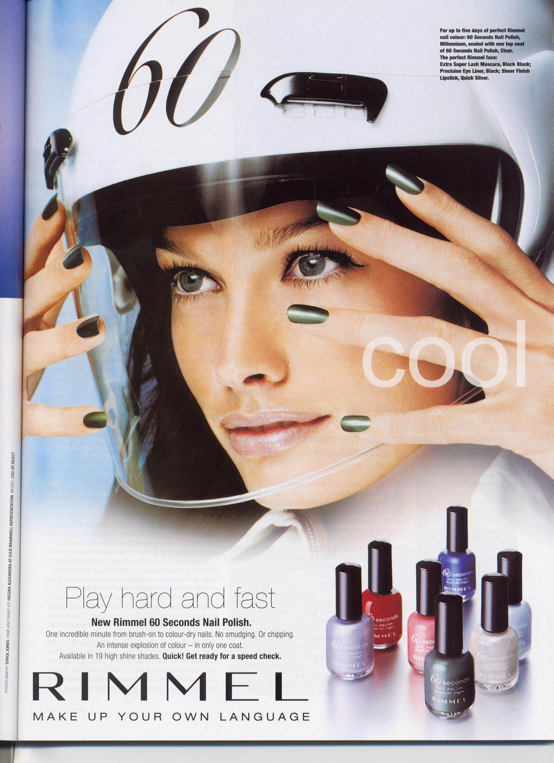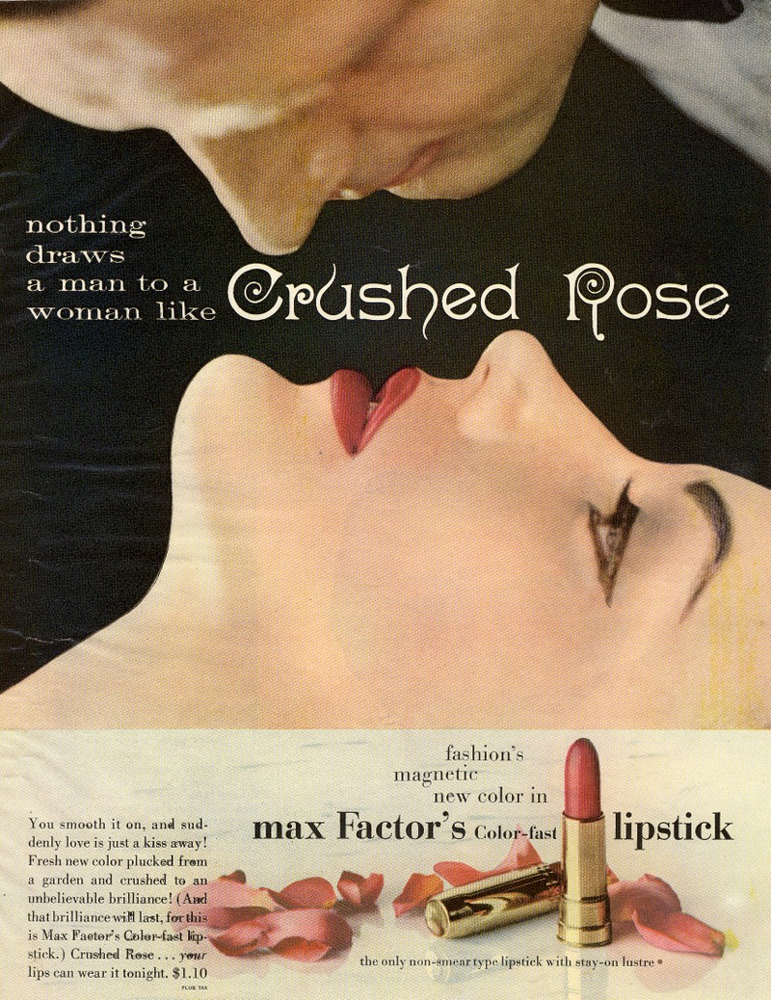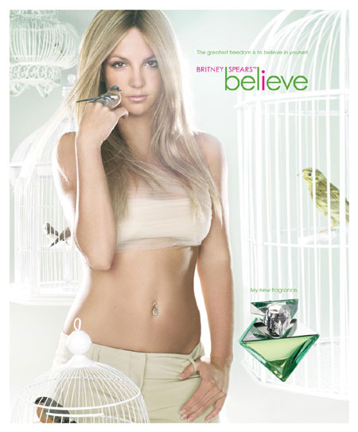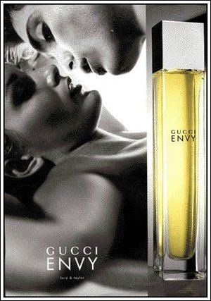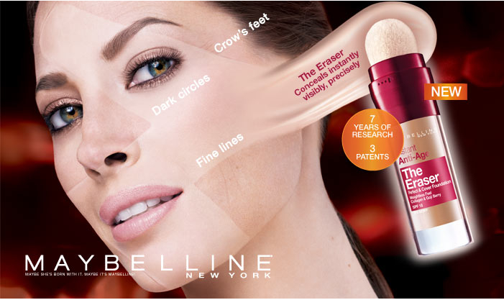

**16. Dramatising historic events – The history of poo**

Research sanitisation development through the years from pre 1800s to today

Take main historical events, implications and consequences, make into a short play.

Write/Draw a cartoon strip to depict events implications and consequences

Cast e.g. Town planner, housewife, family, scientist etc

**Integrated subject options**

1. – Literacy – Research

– Books

ICT – internet search, pictures, publication

19. Literacy - Write a report about what happens at each stage of sanitisation

development, include what the implications of the change were.

ICT – or an article for Publication

20. Literacy - Dictionary work to identify meaning of all new subject specific words

27. Art/ literacy – Draw cartoon strip that captures the historical events and

their implications.

**20. Dictionary work –** can be used as standalone task or extension task

A list of words that students can add to as they come across new words

Look up word, write down meaning

Write word in a sentence to show understanding

**21. Write up**

What happens at each stage of the water treatment plant in detail, include what happens, and why, what is that stage doing to the water to clean it?

**Integrated subject options**

1. – Literacy – Research how water treatment plant works information and pictures

– Books

ICT – internet search, pictures, publication

19. Literacy - Write a report about what happens at each stage in the water

treatment plant

ICT – or an article for Publication

20. Literacy - Dictionary work to identify meaning of all new subject specific words

**22. Debate subjects – Using information gained from Brainstorm (1.)** use questioning, thinking, answering to extend their current knowledge and consolidate new knowledge.

What makes people continue to do things that are bad for the environment? Talk about household products and their ingredients and start thinking about traditional cleaning products.

What would make people change their habits? After survey, talk about results and why people bought the products that they did. How might you convince them to change? What part does advertising play in people’s choices?

Choose subject for debate after initial discussion with students choosing to argue for or against.

**25. Short introduction to Water– Interview with a water drop (short play)**

**Interview**

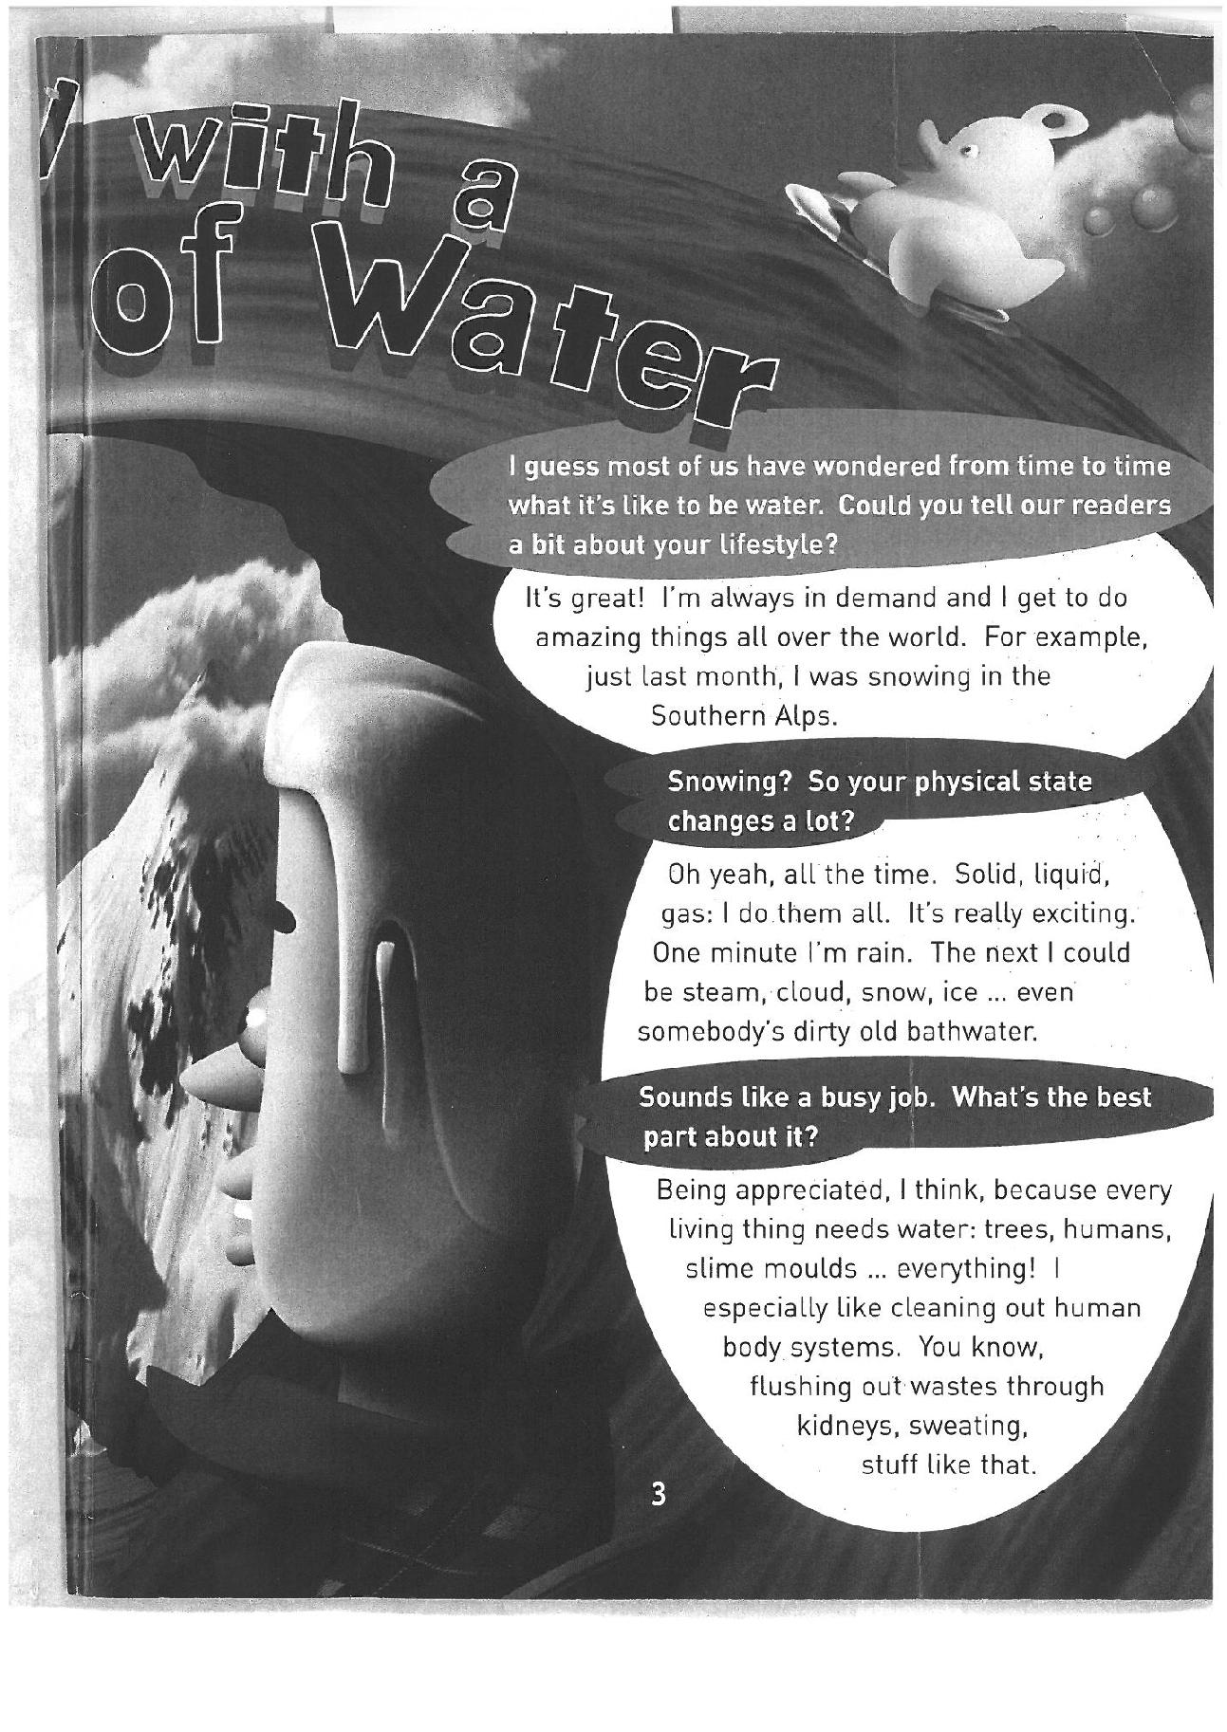

**Drop**

**Interviewer**

Water

**Interviewer**

Water

**Interviewer**

Water

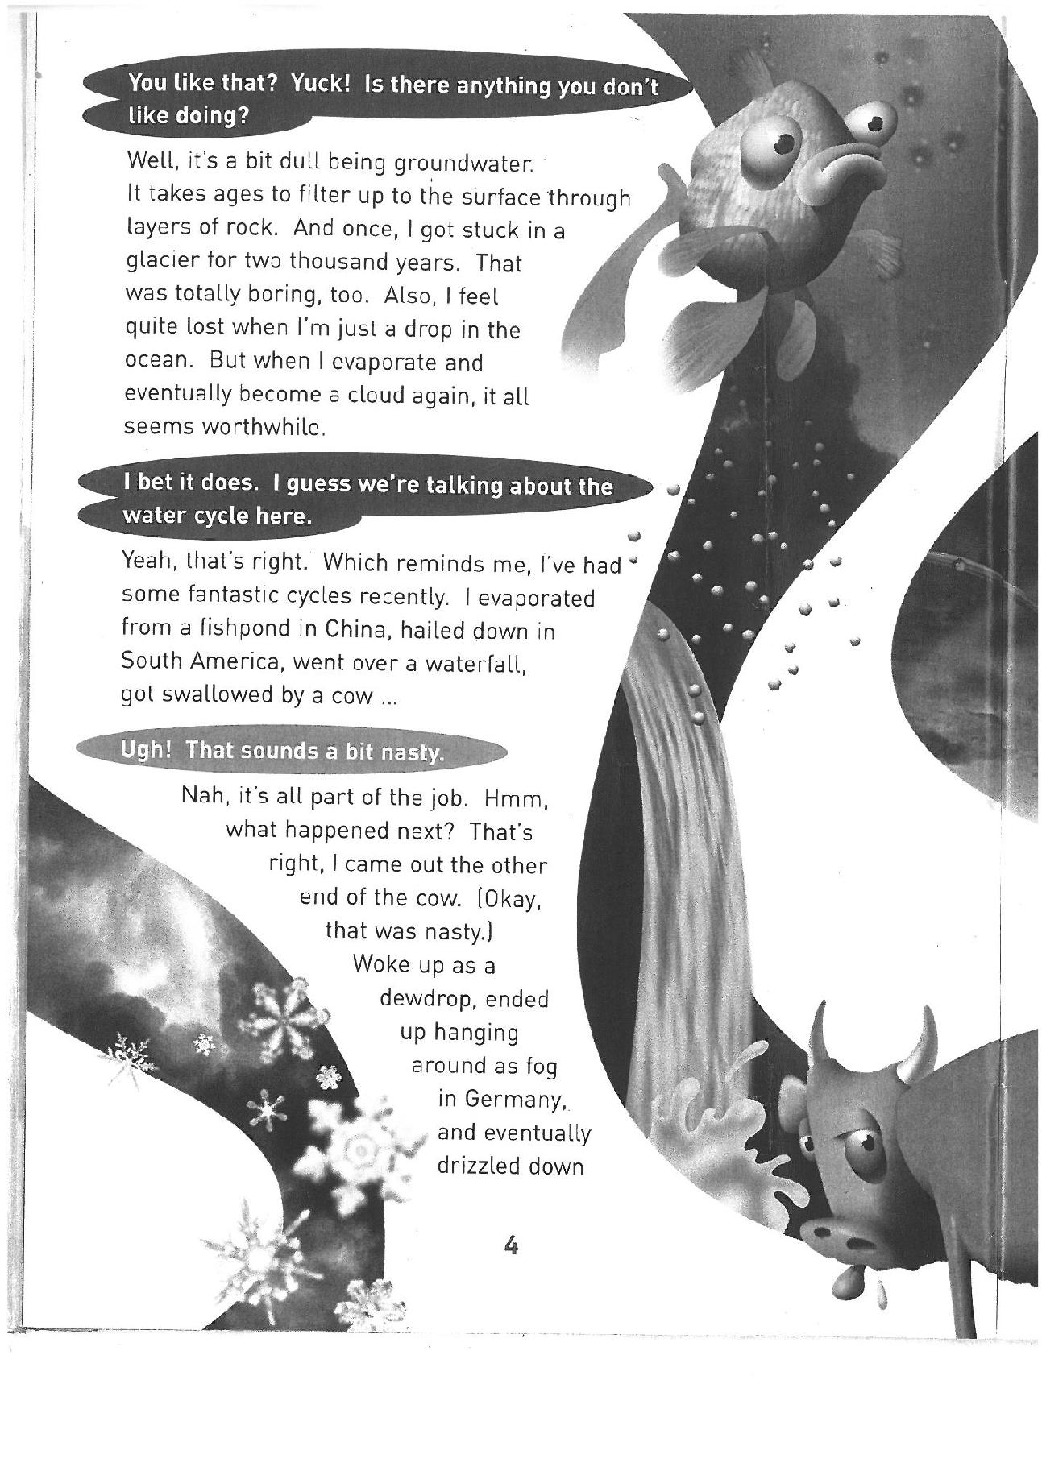

**Interviewer**

Water

**Interviewer**

Water

**Interviewer**

Water

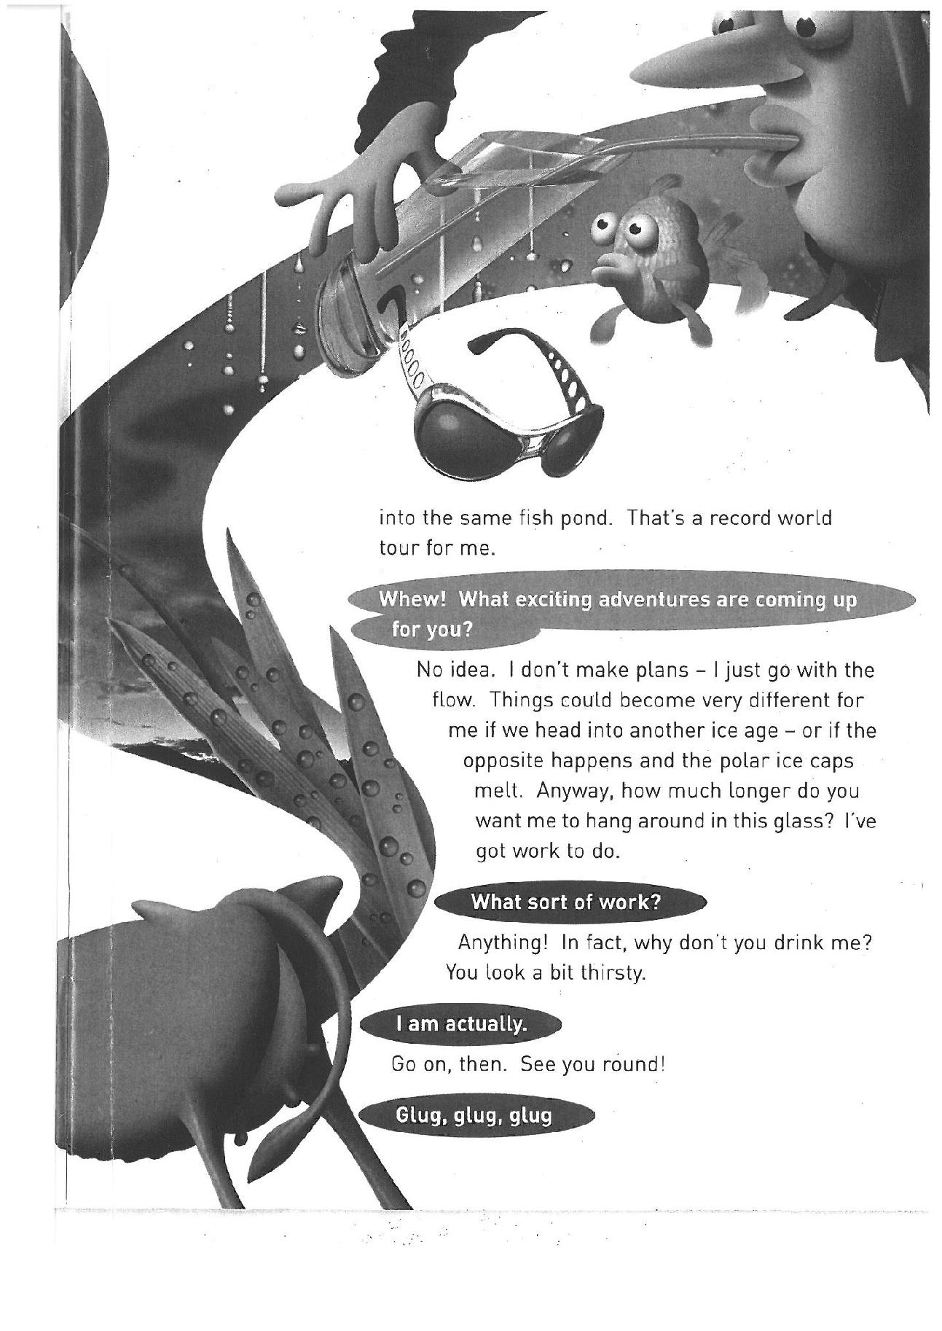

Water

**Interviewer**

Water

**Interviewer**

Water

**Interviewer**

Water

**Interviewer**

**26. Our Water is Precious – He Taonga te Wai**

After interview

Brainstorm knowledge about water (see teacher resources for answers)

Question/answer session, teacher leads but students can take questions once into it

If I got myself a glass of water from the tap, how old is the water in the glass?

How much of the Earth is covered with water?

How much of that water is fresh, drinkable?

How much of the fresh water is available to us to use?

Where is all the fresh water?

So why is it so important to look after our natural waterways?

What can we do to help?

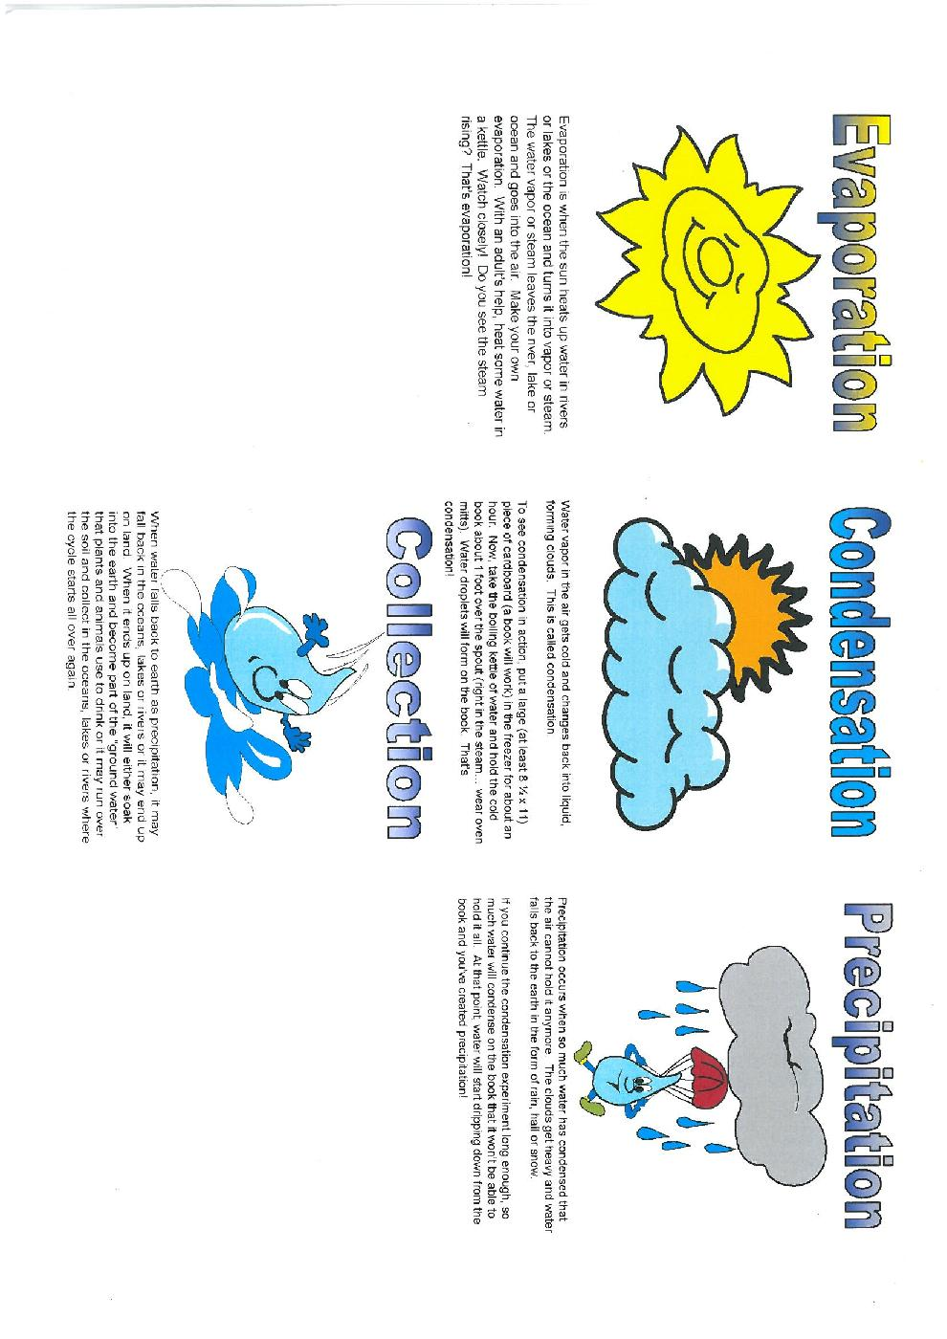**The Water Cycle**

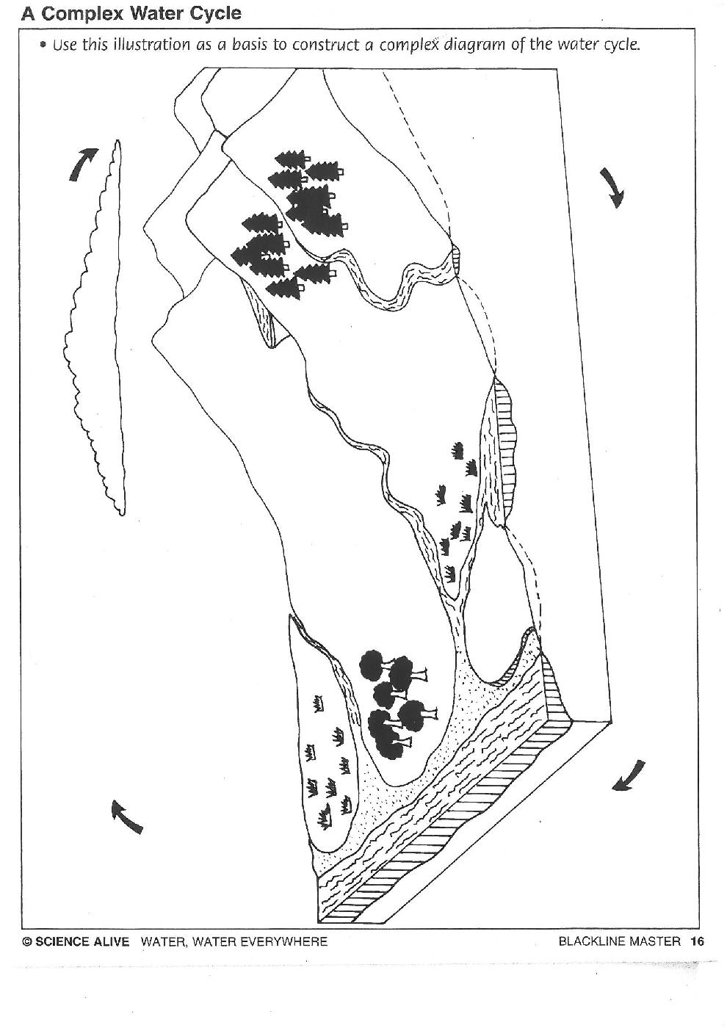

The Water Cycle



**27. Cartoon Strip** Name**………………………………………………………………………………….**



**28. Build your own water filter.-** pair,small group or individual work

Using simple equipment students build their own water filter and prepare their own ‘dirty’ water.

**Resources required:**

Coke bottle

Scissors

Clean sand

Clean gravel

Cotton wool

Container for ‘dirty water’ mixing

Soil, leaves, twigs, etc to make water dirty

**Integrated subject options**

**18. Literacy** – Students complete an experimental report before, during and after practical.

Hypothesis, equipment, methods, result, conclusion (what could they do differently next time).

Pair and small group work could include decision making about sharing chores, who will prepare dirty water? Who will record equipment/methods? Who will build filter? Who will read/listen to instructions?

**29. PACMAN end of day quiz**

Daily quiz on anything you have been learning throughout the week, especially science, repeat questions to enable those who didn’t know answer to hear again and consolidate knowledge.

Have a point system, daily winner gets points, weekly winner get reward.

Rewards: anything from some free time on Friday afternoon, to extra computer time, to choosing what class will do on Friday afternoon, eg. Outside play, put on plays, board games, sports, art, etc etc

**30. Create Your Own Water Cycle**

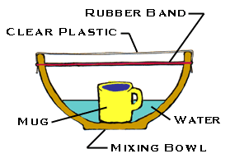

You will need:

* a large metal or plastic bowl
* a pitcher or bucket
* a sheet of clear plastic wrap
* a dry ceramic mug (like a coffee mug)
* a long piece of string or large rubber band
* water

1. Put the bowl in a sunny place outside.
2. Using the pitcher or bucket, pour water into the bowl until it is about ¼

full.

1. Place the mug in the center of the bowl. Be careful not to splash any water into it.
2. Cover the top of the bowl tightly with the plastic wrap.
3. Tie the string around the bowl to hold the plastic wrap in place.
4. Watch the bowl to see what happens.

The "mist" that forms on the plastic wrap will change into larger drops of water that will begin to drip. (You can speed up the dripping by carefully moving the bowl – don't splash! – into the shade.) When this happens, continue watching for a few minutes, then carefully peel back the plastic. Is the coffee mug still empty? Water from the "ocean" of water in the bowl evaporated. It  condensed to form misty "clouds" on the plastic wrap. When the clouds became saturated it "rained" into the mug!